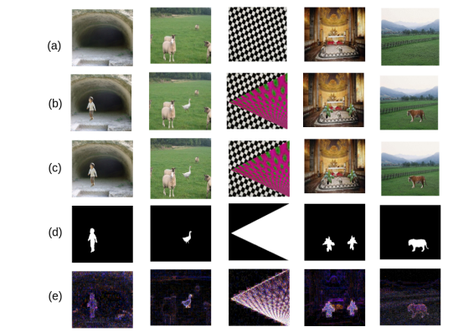

Various sample images and their processed forms: (a) the original images (RGB colour format); (b) the images with forgery (RGB colour format); (c) the recompressed forged images (RGB colour format); (d) ground truth of forgery (Binary format); (e) difference of the tampered image with its recompressed image (RGB colour format).

The feature image (Adi f f) is resized to 128 × 128 (Areshaped_di f f) and then fed to the network. The network learns the presence of any tampering present through the feature images (images shown in Figure 1e). During training, the proposed model learns the existence of the forgery in an image through the numerous artifacts left behind during image forgery. The trained model can identify tampering with high accuracy, discussed in the next section.

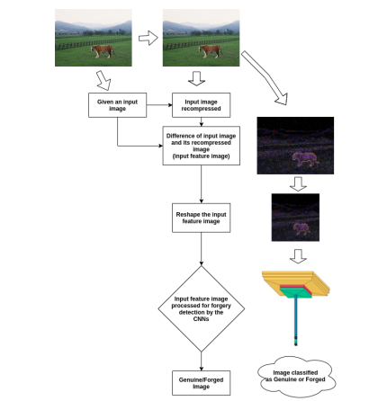

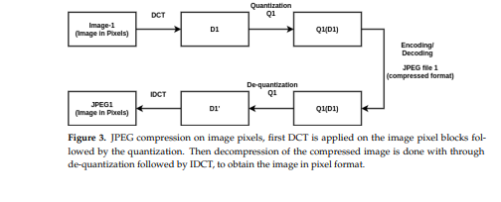

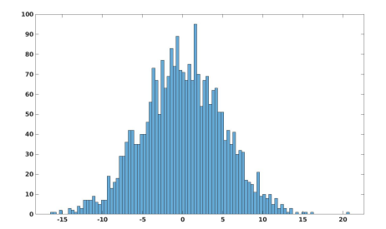

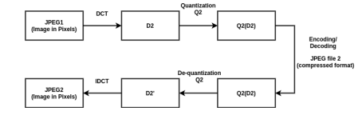

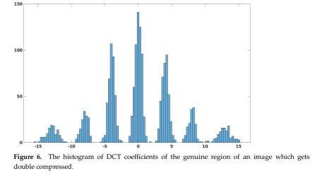

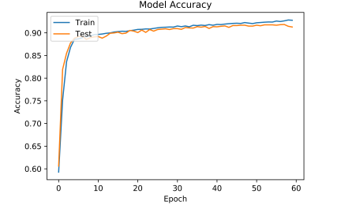

**Comparison with Other Techniques :**

We compare the proposed technique to the other techniques in terms of accuracy and time required for image forgery detection.

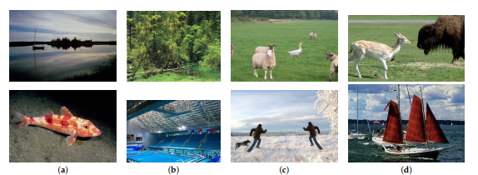

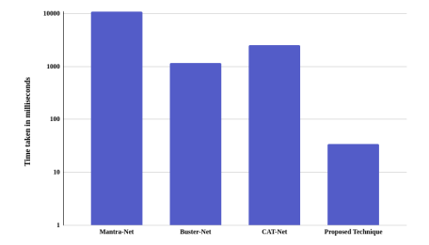

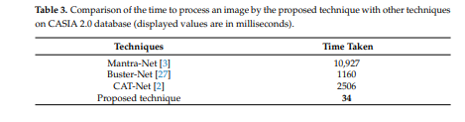

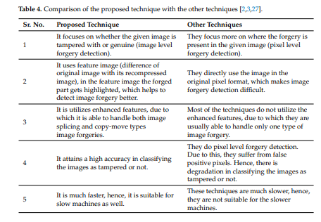

### Download the Correct version into the system

**Step 1:** Go to the official site to download and install python using Google Chrome or any other web browser. OR Click on the following link: [https://www.python.org](https://www.python.org/)

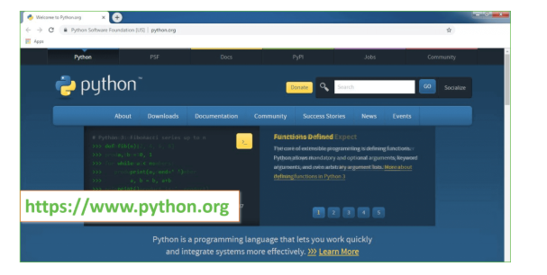

Now, check for the latest and the correct version for your operating system.

**Step 2:** Click on the Download Tab.

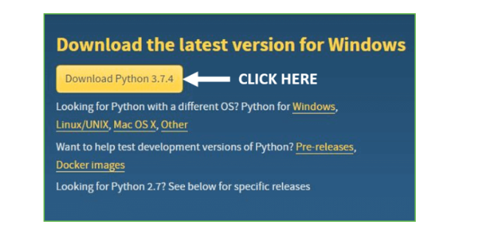

**Step 3:** You can either select the Download Python for windows 3.7.4 button in Yellow Color or you can scroll further down and click on download with respective to their version. Here, we are downloading the most recent python version for windows 3.7.4

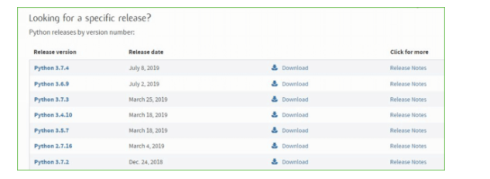

**Step 4:** Scroll down the page until you find the Files option.

**Step 5:** Here you see a different version of python along with the operating system.

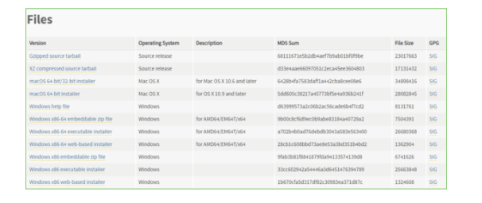

• To download Windows 32-bit python, you can select any one from the three options: Windows x86 embeddable zip file, Windows x86 executable installer or Windows x86 web-based installer.

•To download Windows 64-bit python, you can select any one from the three options: Windows x86-64 embeddable zip file, Windows x86-64 executable installer or Windows x86-64 web-based installer.

Here we will install Windows x86-64 web-based installer. Here your first part regarding which version of python is to be downloaded is completed. Now we move ahead with the second part in installing python i.e. Installation

**Note:** To know the changes or updates that are made in the version you can click on the Release Note Option.

### Installation of Python

**Step 1:** Go to Download and Open the downloaded python version to carry out the installation process.

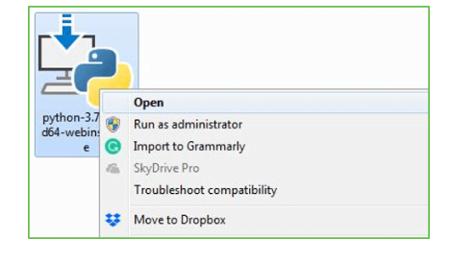

**Step 2:** Before you click on Install Now, Make sure to put a tick on Add Python 3.7 to PATH.

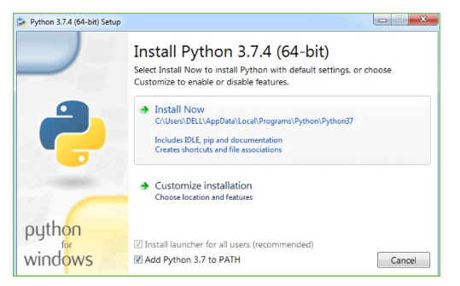

**Step 3:** Click on Install NOW After the installation is successful. Click on Close.

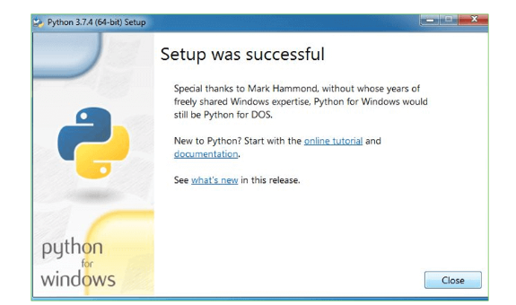

With these above three steps on python installation, you have successfully and correctly installed Python. Now is the time to verify the installation.

**Note:** The installation process might take a couple of minutes.

### Verify the Python Installation

**Step 1:** Click on Start

**Step 2:** In the Windows Run Command, type “cmd”.

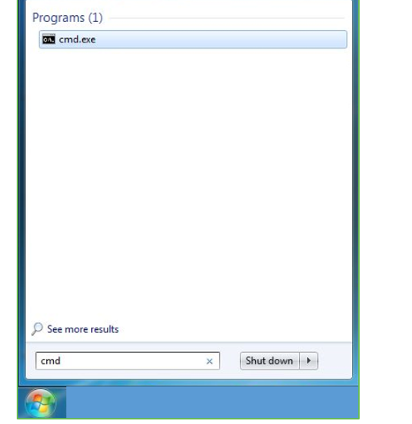

**Step 3:** Open the Command prompt option.

**Step 4:** Let us test whether the python is correctly installed. Type **python –V** and press Enter.

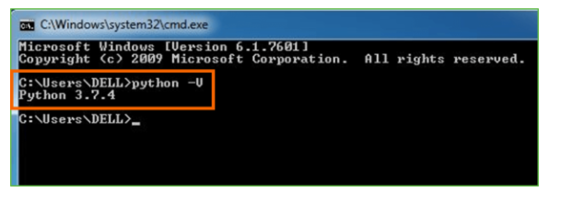

**Step 5:** You will get the answer as 3.7.4

**Note:** If you have any of the earlier versions of Python already installed. You must first uninstall the earlier version and then install the new one.

### Check how the Python IDLE works

**Step 1:** Click on Start

**Step 2:** In the Windows Run command, type “python idle”.

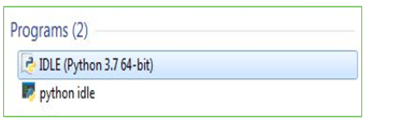

**Step 3:** Click on IDLE (Python 3.7 64-bit) and launch the program

**Step 4:** To go ahead with working in IDLE you must first save the file. **Click on File > Click on Save**

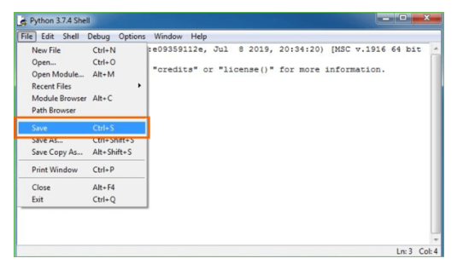

**Step 5:** Name the file and save as type should be Python files. Click on SAVE. Here I have named the files as Hey World.

**Step 6:** Now for e.g. **enter print**

**SCREENSHOTS :**

To run project double click on ‘run.bat’ file to get below output

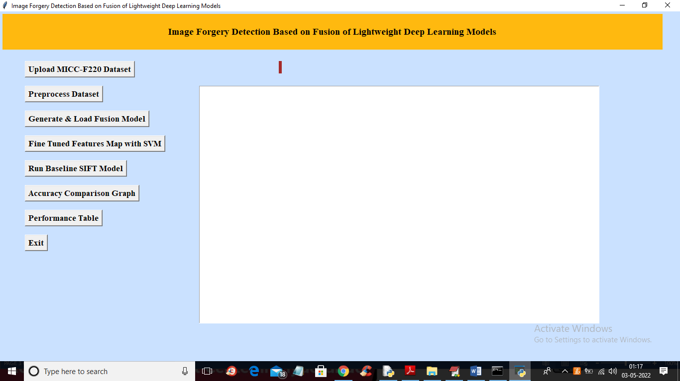

In above screen click on ‘Upload MICC-F220 Dataset’ button to upload dataset and get below output

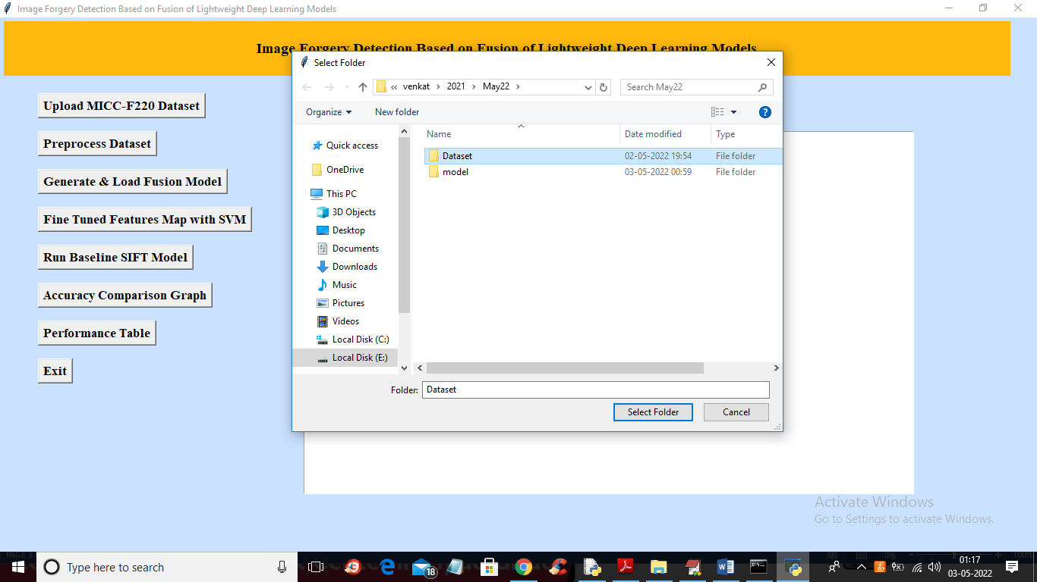

In above screen selecting and uploading ‘Dataset’ folder and then click on ‘Select Folder’ button to load dataset and get below output

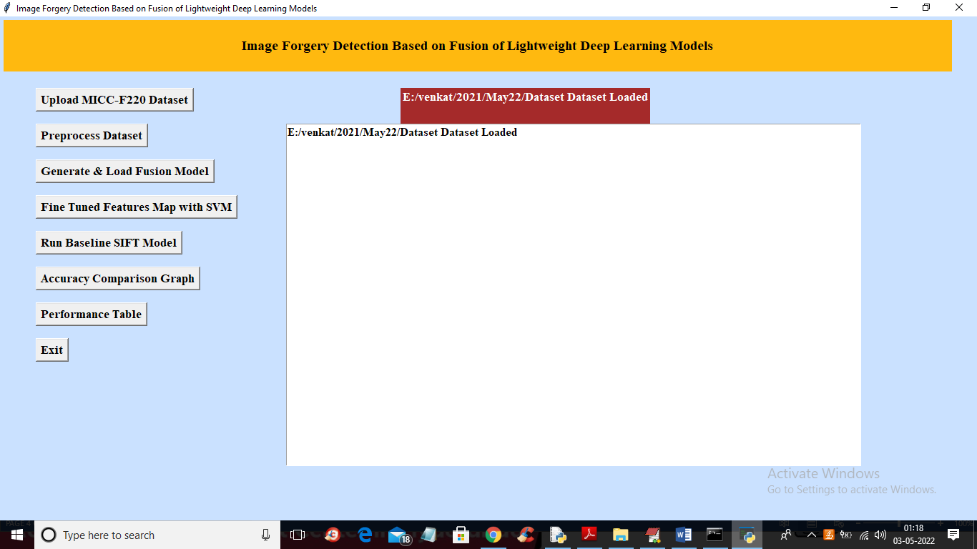

In above screen dataset loaded and now click on ‘Preprocess Dataset’ button to read all images and normalize them and get below output

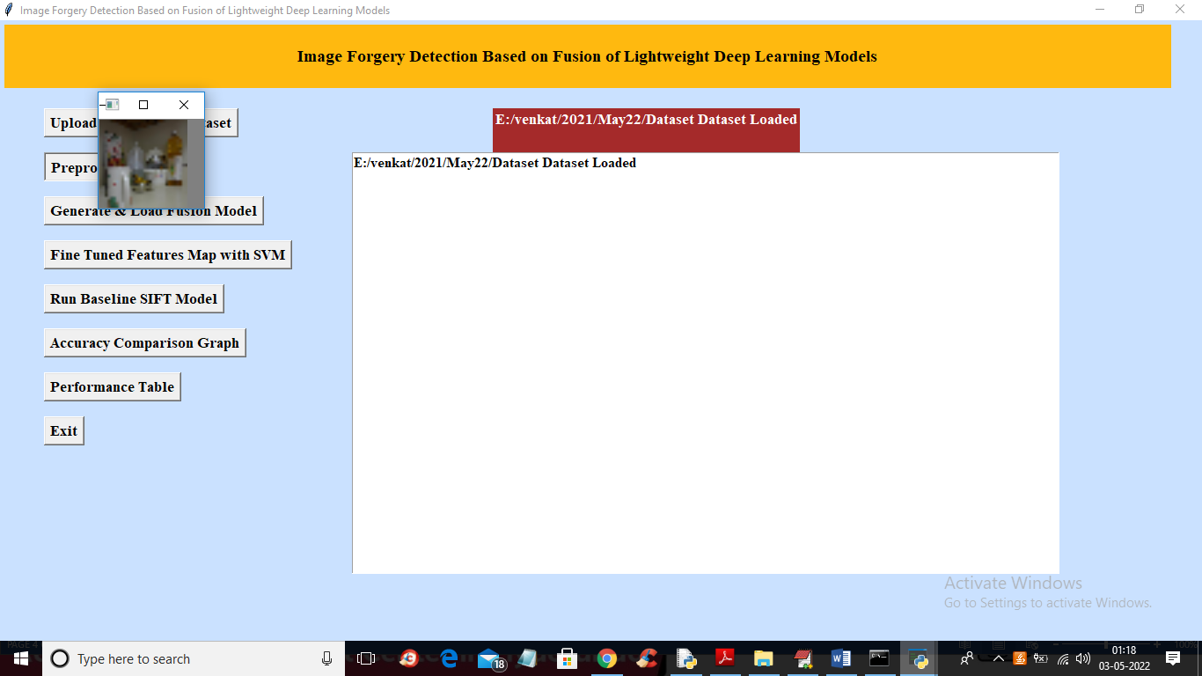

In above screen all images are processed and to check images loaded properly I am displaying one sample image and now close above image to get below output

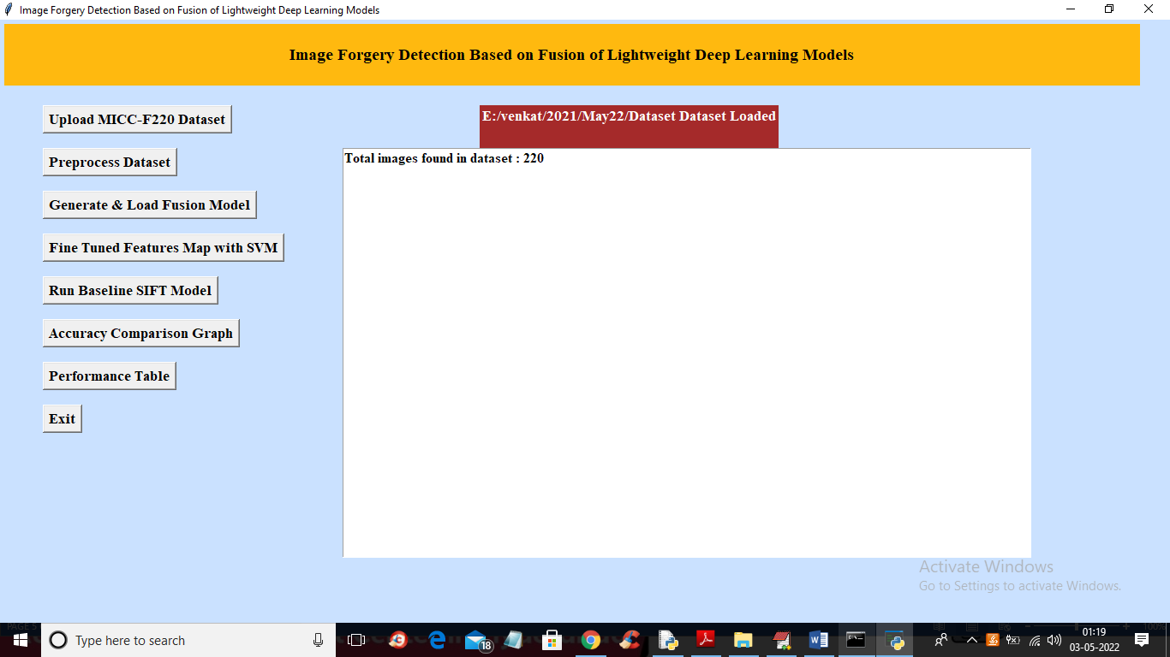

In above screen we can see dataset contains 220 images and all images are processed and now click on ‘Generate & Load Fusion Model’ button to train all algorithms and then extract features from them and then calculate their accuracy

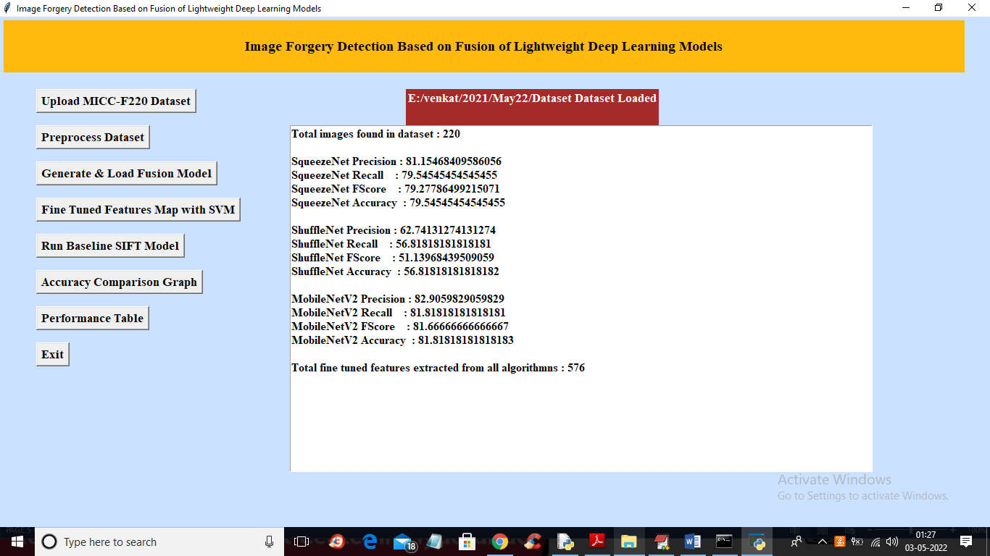

In above screen we can see accuracy of all 3 algorithms and then in last line we can see from all 3 algorithms application extracted 576 features and now click on ‘Fine Tuned Features Map with SVM’ to train SVM with extracted features and get its accuracy as fusion model

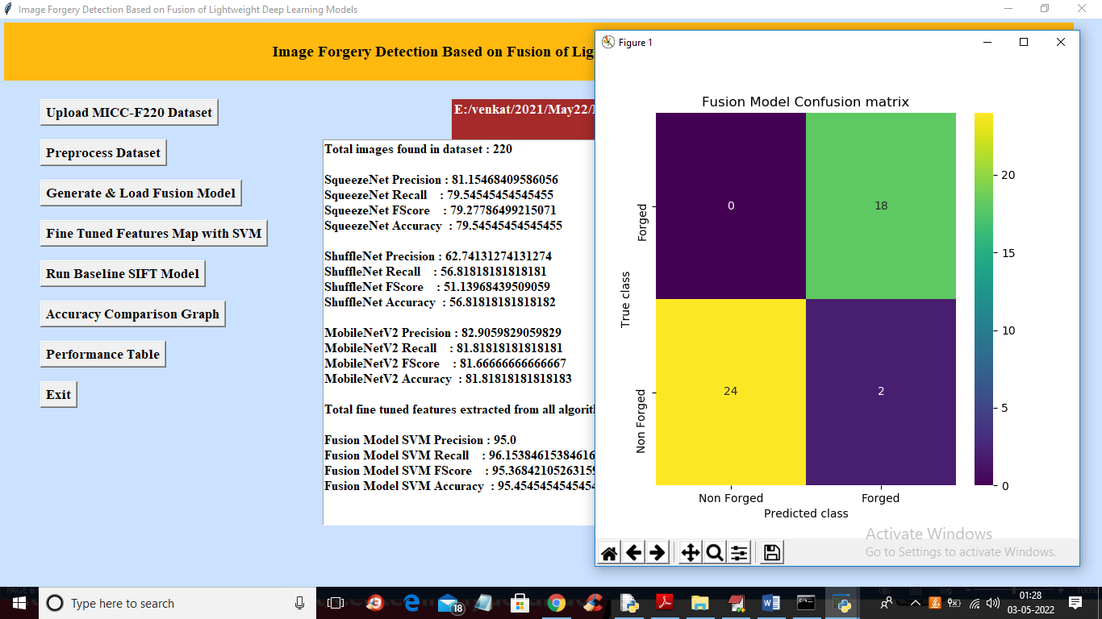

In above screen with Fine tune SVM fusion model we got 95% accuracy and in confusion matrix graph x-axis represents PREDICTED LABELS and y-axis represent TRUE labels and we can see both X and Y boxes contains more number of correctly prediction classes. In all algorithms we can see fine tune features with SVM has got high accuracy and now close confusion matrix graph and then click on ‘Run Baseline SIFT Model’ button to train SVM with SIFT existing features and get its accuracy

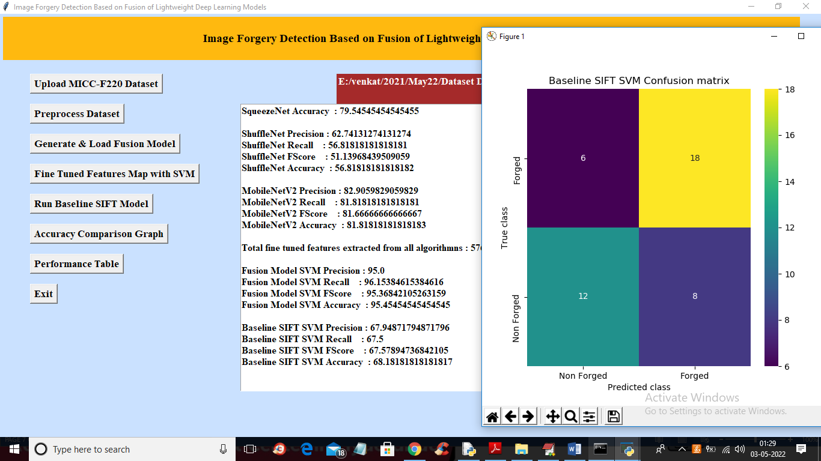

In above screen with existing SIFT SVM features we got 68% accuracy and in confusion matrix graph we can see existing SIFT predicted 6 and 8 instances incorrectly. So we can say existing SIFT features are not good in prediction and now close above graph and then click on ‘Accuracy Comparison Graph’ button to get below graph

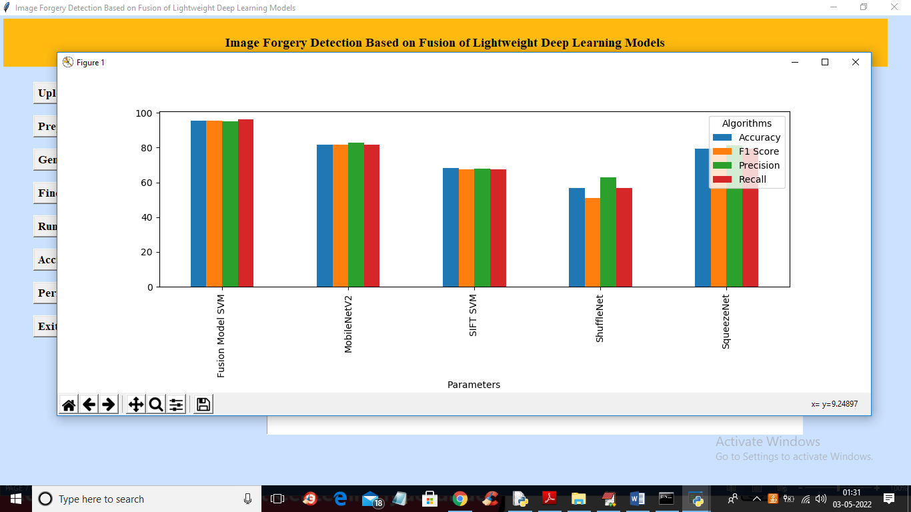

In above graph x-axis represents algorithm names and y-axis represents accuracy and other metrics where each different colour bar represents different metrics like precision, recall etc. Now close above graph and then click on ‘Performance Table’ button to get result in below tabular format

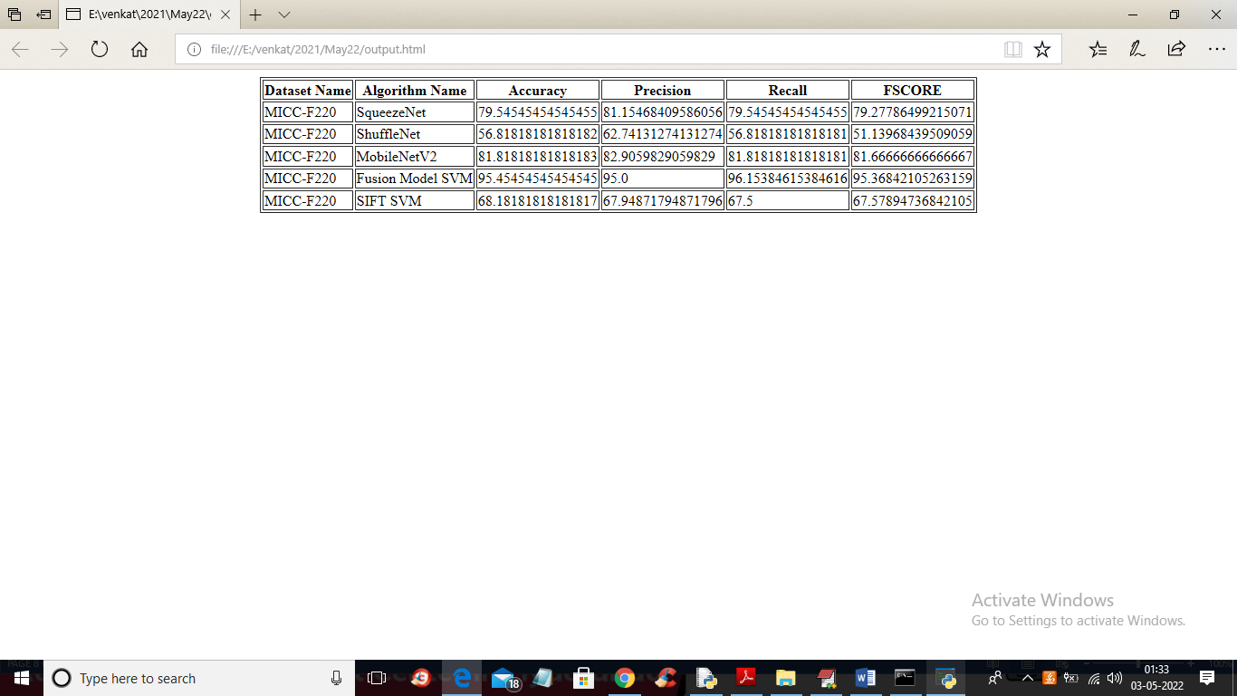

In above screen we can see propose fusion model SVM with fine tune features has got 95% accuracy which is better than all other algorithms